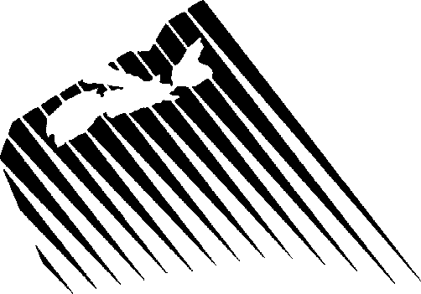Canada - Nova Scotia Offshore Petroleum Board

Call For Bids NS14-1: Confirmation of Operating Experience Form

Pursuant to the terms and conditions of the Canada Nova Scotia Offshore Petroleum Board Call for Bids NS14-1, (name), as representative of the Bidder hereby confirms that
(the Bidder, its parent company or an affiliated company) has operated or has been a joint operator in the drilling of deepwater exploration wells in water depths greater than 800 meters in the past ten (10) years. Details for each well are
provided below.

Well Name | Location | Year Drilled | Water Depth (m) | Total Depth (m MD)

Any Additional Comments:

Declaration

The undersigned representative is an officer, director or other Person employed by the Bidder who has the requisite authority to make this declaration and hereby declares he or she has examined the above noted confirmation of operating experience and list of wells, and that the information given here is, to the best of his or her knowledge, true, accurate and complete; and acknowledges that information submitted may be subject to an audit by the Canada-Nova Scotia Offshore Petroleum Board or a representative of the Canada-Nova Scotia Offshore Petroleum Board.

Signed Date:
Representative

Print Name:

Title:

Address:_
Phone:

Email:

